Final Assessment-Alternative Assessment
Semester | 202520 | Division | CIS
Assessment title in Syllabus | Final_Project_Portfolio | Program | Bachelor of Information Technology/ Bachelor of Information Systems
Course Code | CDS 2413
Course Title | INTRODUCTION TO DATA SCIENCE
Course Instructor |  | CRN
Assessment | Project Deliverable 1 – Data Analysis Report | Submission Date | Week 6
Student Declaration:
Academic Integrity Statement
In accordance with the HCT Academic Integrity Policy
• Students are required to refrain from all forms of academic integrity breaches as defined and explained by HCT.
• A student found guilty of having committed acts of academic integrity breach(es) will be subject to the relevant sanctions as outlined by HCT.
إفادة النزاهة الأكاديمية
وفقًا لسياسة كليات التقنية العليا للنزاهة الأكاديمية
• على الطلبة الإلتزام بلوائح وقواعد النزاهة الأكاديمية، كما هو مبيّن وموضح في السياسات والإجراءات الخاصة بكليات التقنية العليا.
• في حالة ارتكاب الطالب أي شكل من أشكال الإخلال بالنزاهة الأكاديمية، سيتعرض الى العقوبات الموضحة في السياسات ذات الصلة.
This assignment is entirely my/our own work except where I have duly acknowledged other sources in the text and listed those sources at the end of the assignment. I have not previously submitted this work to the HCT, or any other entity. I understand that I may be orally examined on my submission.

Student HCT ID(s): | H00 | H00 | H00 | H00
Student Name(s):
Student Signature
Chatbot (e.g. ChatGPT) statement
This submission allows you to use AI generated tools, but the prompt used must be stated and the response must be in red font. Include References to ChatGPT.

Instructions

Remove instructions and hints from the template before submitting the final report to BBLearn.

Table of Contents
CLO1: Introduction and Data Wrangling (5 Points) 4
Purpose of Data Analysis (1 point) 4
Type of Programming (1 point) 4
Type and Purpose of ML algorithm (1 point) 5
Identify the Varaibles (1 point) 5
Sampling (1 point) 6
CLO2: Descriptive, Exploratory and Statistical Analysis (10 Points) 7
Purpose of Descriptive Analysis (1 point) 7
Script for Descriptive Analysis (1 point) 7
Random Sampling (1 point) 8
Systematic Sampling (1 point) 8
Descriptive Statistical Report (1 point) 9
Visualisation through Various Charts (2 points) 10
Hypothesis Test (1 point) 13
One Sample T-test (2 points) 16

CLO1: Introduction and Data Wrangling (5 Points)

Purpose of Data Analysis (1 point)
The purpose of this data analysis is to examine the medical insurance dataset and understand the factors that affect insurance charges. The dataset includes several variables such as age, gender, body mass index (BMI), number of children, smoking status, region, and medical insurance charges.
In this project, we want to study how these independent variables influence the dependent variable, which is the insurance charges. We aim to explore whether factors like smoking, age, or BMI increase the cost of insurance. By analyzing the data, we can identify patterns, trends, and relationships between the variables.
This analysis is important because medical insurance costs can vary between individuals. Understanding the main factors that affect these costs can help insurance companies improve their pricing strategies. It can also help individuals understand what increases their medical expenses. Overall, this project supports data-driven decision-making by using statistical analysis and visualization techniques.

Type of Programming (1 point)

- Python was selected because it provides powerful libraries that support data cleaning, analysis, statistical analysis, and hypothesis testing in one environment.

- The Pandas library will be used to load and manipulate the dataset, perform sampling, and calculate descriptive statistics.

- Numerical computations and mathematical operations were done with the NumPy library.

- The Matplotlib and Seaborn libraries were used to generate visualizations such as scatter plots, box plots, histograms, and heat maps to better understand patterns and relationships in the data.

Type and Purpose of ML algorithm (1 point)
The type of machine learning used in this project is Supervised Learning. Supervised learning is used when there is a dependent variable that we want to analyze or predict using other independent variables.
In this dataset, the dependent variable is insurance charges, which is a numerical value. Since the target variable is numeric, the suitable approach is Regression, which is a type of supervised learning. Regression helps us understand how different factors such as age, BMI, smoking status, and number of children influence insurance charges.
The purpose of using this method is to examine the relationship between the independent variables and the insurance cost. It helps identify the most important factors that increase medical expenses and supports data-driven decision-making.

Identify the Varaibles (1 point)
- Dependent Variable:
- Insurance Charges
• This is the dependent variable because it represents the outcome we want to analyze.
• Insurance charges depend on personal and health-related factors included in the dataset.
• The goal of this project is to understand what increases or decreases medical insurance costs.
- Independent Variables:
- Age - Older individuals may have higher medical risks, which can increase insurance charges.
- BMI - Higher BMI may be associated with health problems, leading to higher insurance costs.
- Smoking Status - Smokers usually have higher medical expenses compared to non-smokers.
- Number of Children - May affect the overall medical coverage and cost.
- Gender - Can influence certain health risks.
- Region - Insurance charges may vary depending on the location.

Sampling (1 point)
In this project, sampling is applied to ensure that the analysis is efficient and manageable. Since the dataset contains many records, sampling helps reduce the size of the data while maintaining its representativeness.
Two types of sampling are used in this study:
• Random Sampling
A random sample of size 150 is selected from the dataset. This ensures that every record has an equal probability of being chosen, which minimizes bias and provides a fair representation of the population.
• Systematic Sampling
A structured sampling method is applied by selecting records using a fixed interval or defined condition. This method ensures organized and consistent data selection for analysis of the dependent variable (insurance charges).
Sampling is important because it allows us to perform descriptive statistics, correlation, and hypothesis testing efficiently while maintaining reliable and statistically valid results.

CLO2: Descriptive, Exploratory and Statistical Analysis (10 Points)

Purpose of Descriptive Analysis (1 point)
Descriptive analysis is performed to summarize and understand the main characteristics of the medical insurance dataset. In this project, the focus is on the dependent variable, which is insurance charges.
By calculating statistical measures such as mean, median, standard deviation, minimum, maximum, and quartiles, we can understand how insurance costs are distributed among individuals. This helps identify patterns, variations, and possible extreme values in the data.
Descriptive statistics provide a strong foundation before performing correlation and hypothesis testing. It ensures that the dataset is clearly understood and suitable for further statistical analysis.

Script for Descriptive Analysis (1 point)
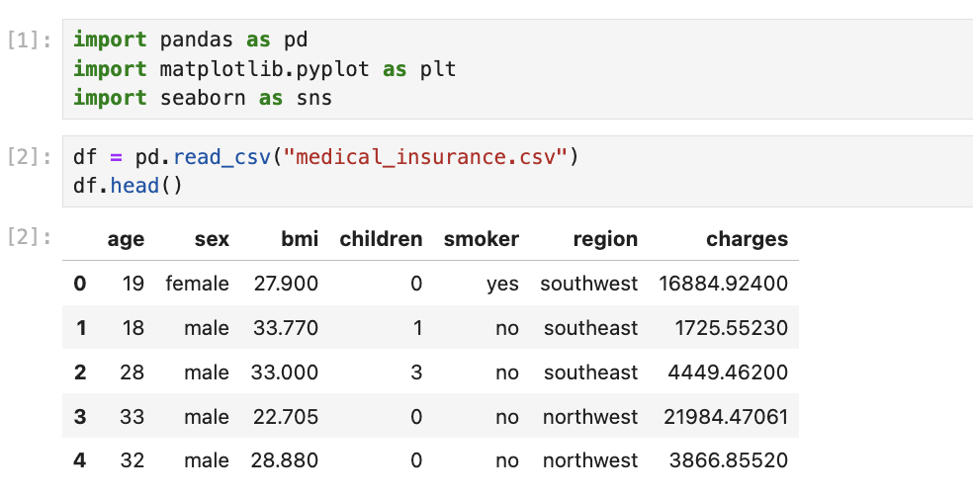
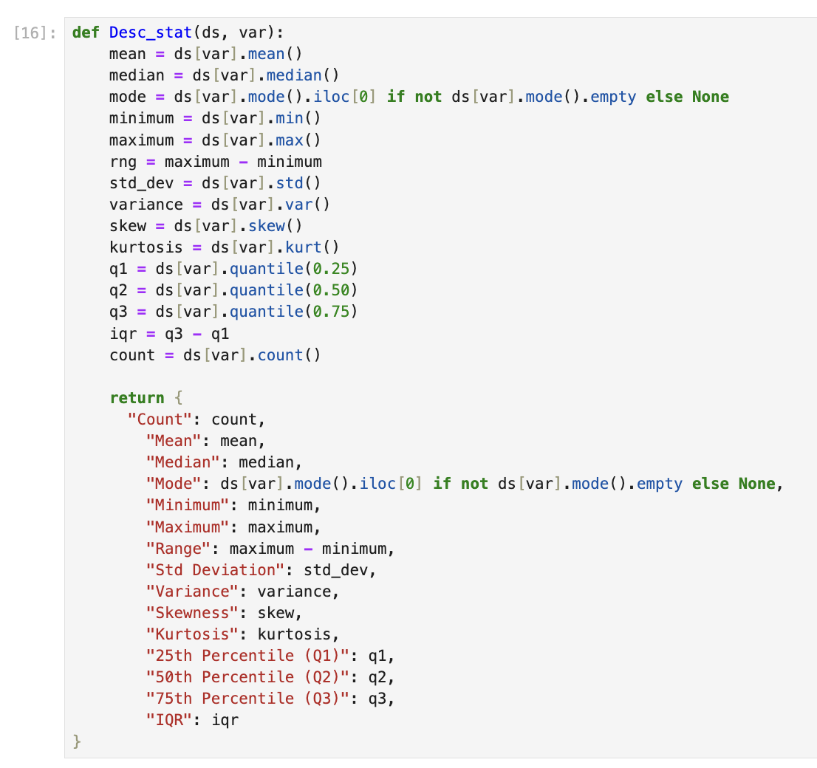

Random Sampling (1 point)
To perform random sampling, a sample of size 150 was selected randomly from the dataset. This ensures that each record has an equal probability of being chosen, which reduces bias and improves fairness in the analysis.
The random sample is then used to calculate descriptive statistics for the dependent variable, which is insurance charges, using the descriptive function created earlier.
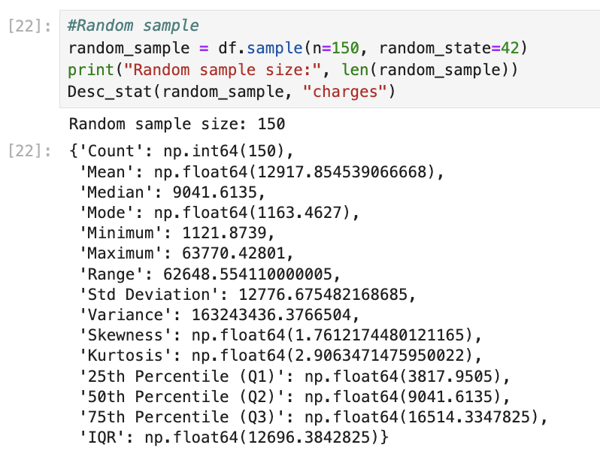

Systematic Sampling (1 point)
Systematic sampling was used by selecting data at a fixed interval from the dataset. The step size was calculated by dividing the total number of records by 150.
Then, descriptive statistics were calculated for the dependent variable, which is insurance charges, to understand how the values are distributed in the systematic sample.
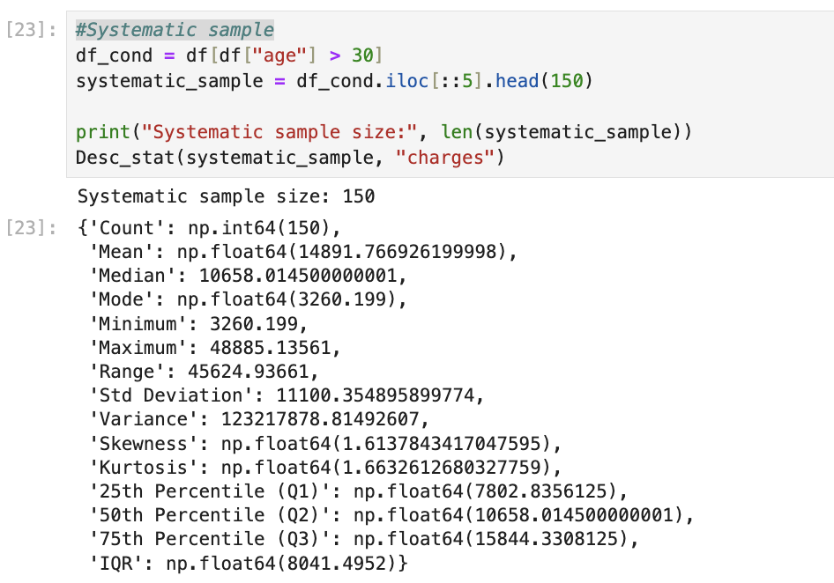

Descriptive Statistical Report (1 point)
The dependent variable in this dataset is insurance charges, which represents the medical cost paid by individuals. Based on the random sample of 150 records, the mean insurance charge is approximately 12,917.85, while the median is 9,041.61. The mean is higher than the median, which suggests that the data is positively skewed due to some very high insurance costs.
The minimum insurance charge in the sample is 1,121.87, while the maximum is 63,770.43. This large difference between the minimum and maximum values indicates a wide range of medical expenses among individuals. The standard deviation is 12,776.68, which shows high variability in insurance charges.
The first quartile (Q1) is 3,817.95, meaning that 25% of individuals pay less than this amount. The third quartile (Q3) is 16,514.33, meaning that 75% of individuals pay less than this value. The interquartile range (IQR) shows that the middle 50% of insurance charges are spread across a wide interval.
Overall, the descriptive analysis indicates that insurance charges vary significantly among individuals, and some extreme values increase the average cost. This suggests that certain factors, such as smoking or high BMI, may strongly influence medical expenses.

Visualisation through Various Charts (2 points)
Scatter Plot
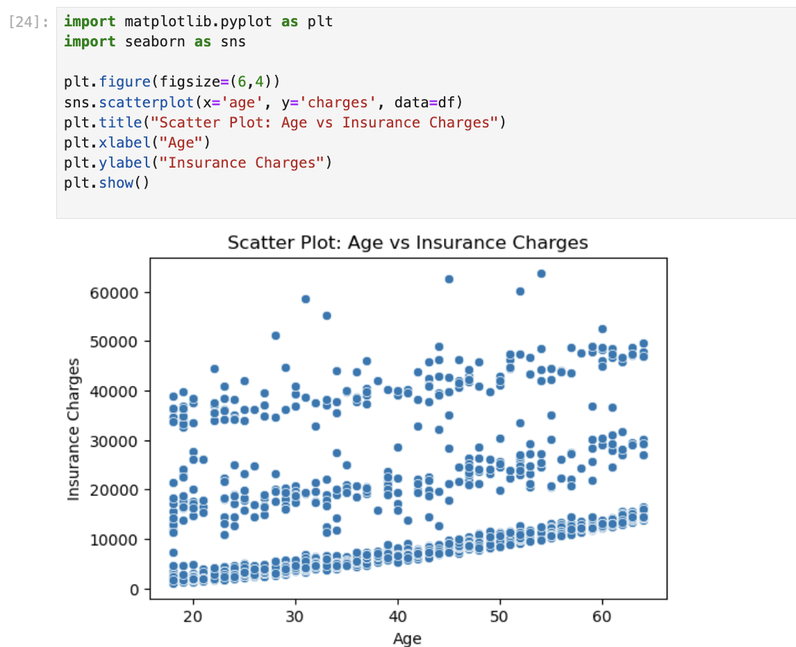
The scatter plot shows a slight positive relationship between age and insurance charges. As age increases, charges also tend to increase, but the relationship is not very strong.
Box Plot

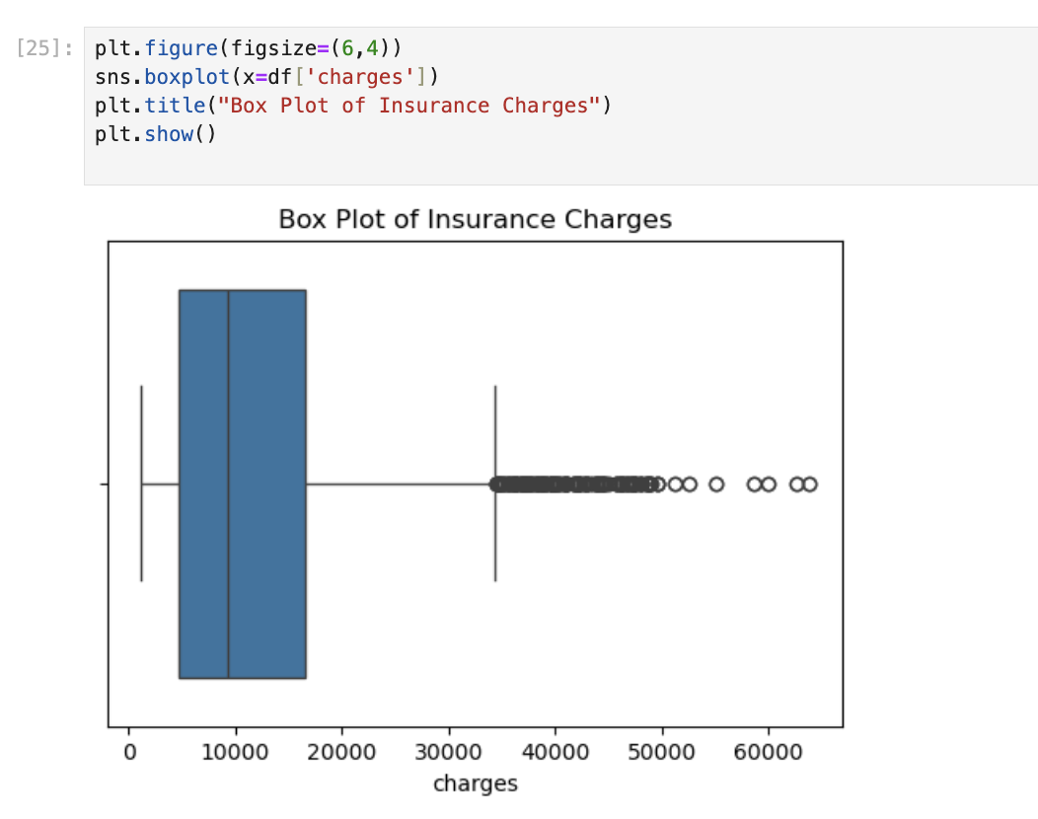
The box plot shows that insurance charges are right-skewed. There are several high outliers, which means some individuals pay very high medical costs.
Histogram

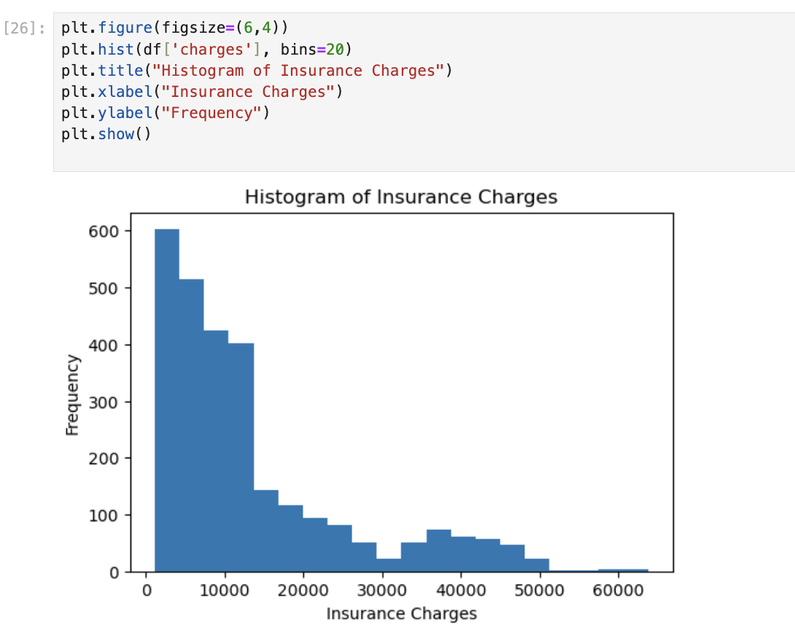
The histogram shows that most insurance charges are in the lower range. The distribution is positively skewed due to a few very high charges.

Heat Map

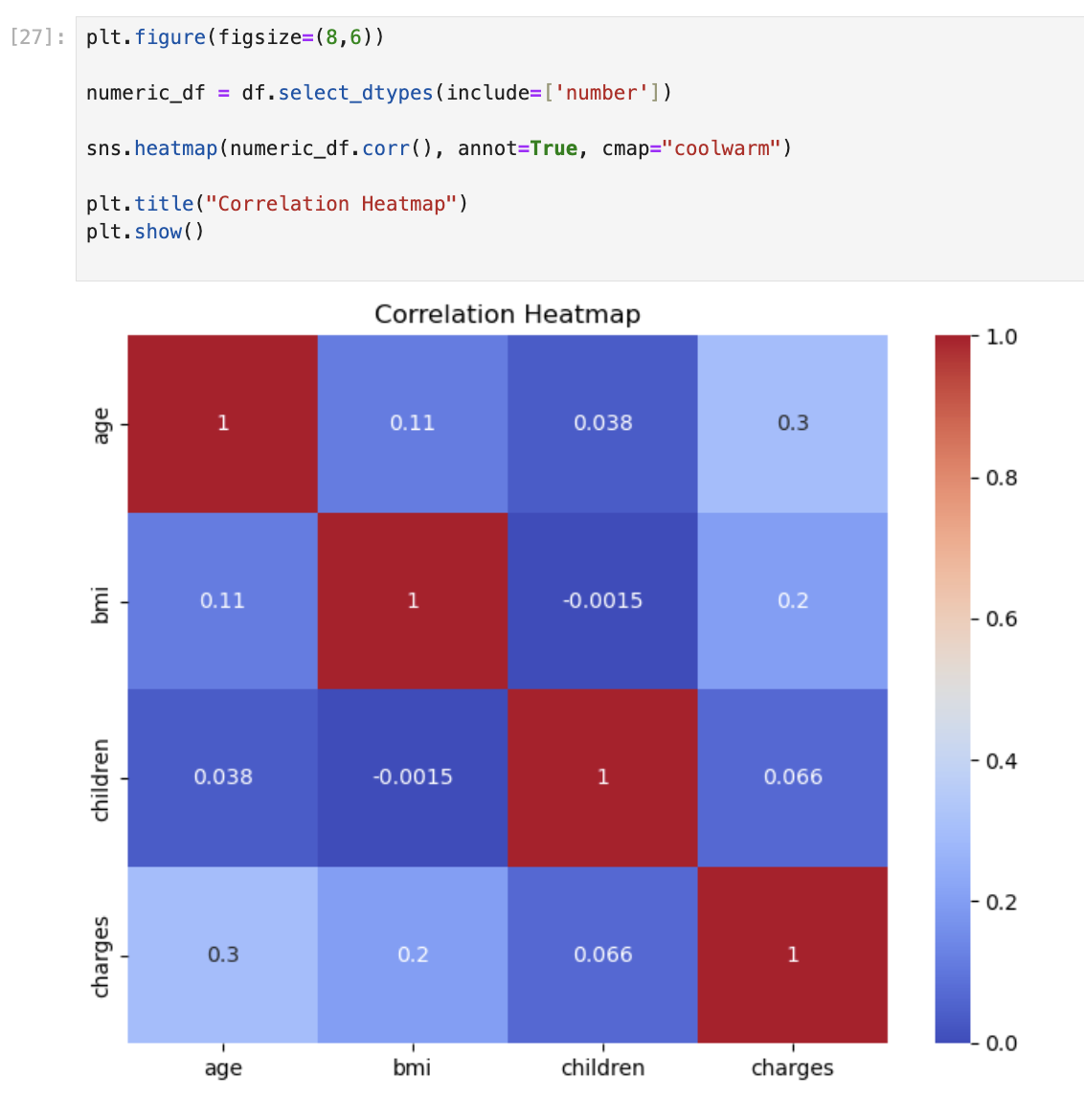
The heatmap shows that age and BMI have a positive correlation with insurance charges. Smoking also appears to strongly affect medical costs.

Hypothesis Test (1 point)

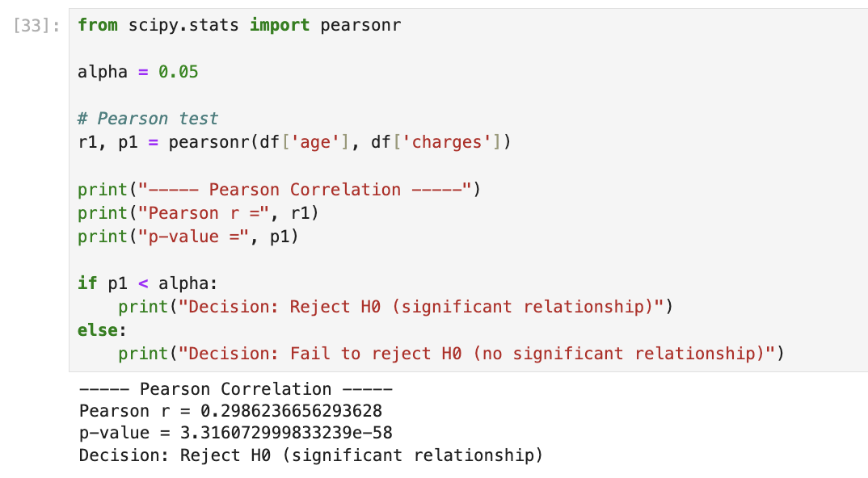

Pearson Correlation Test

Hypotheses
H₀: There is no linear relationship between age and insurance charges.
H₁: There is a linear relationship between age and insurance charges.
Results
Pearson Correlation Coefficient: 0.2986
P-value: 3.3160
Interpretation
Since the p-value is less than 0.05, we reject the null hypothesis.
This means there is a statistically significant positive linear relationship between age and insurance charges. As age increases, insurance charges tend to increase.

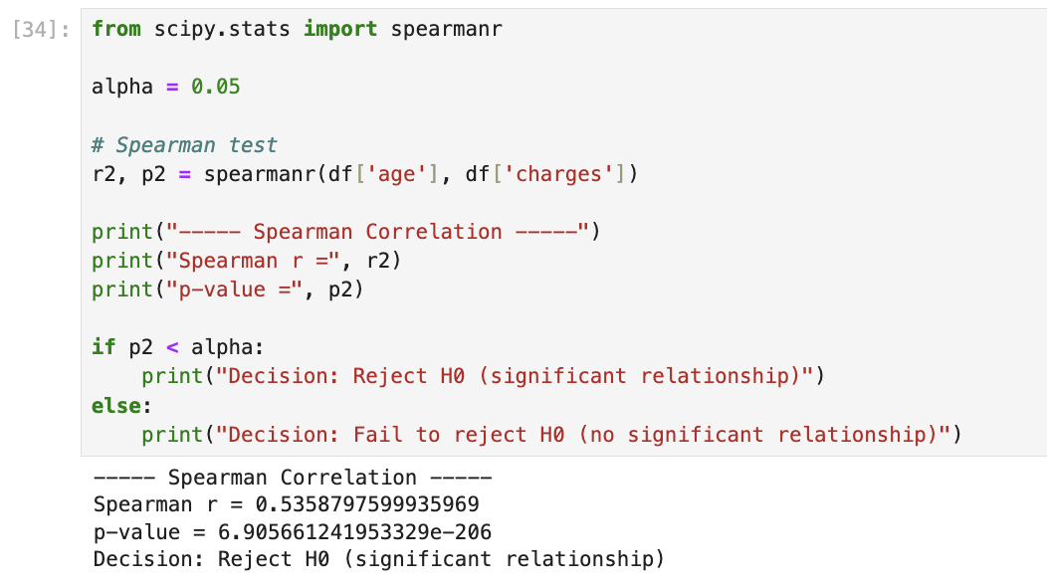
Spearman Correlation Test
Hypotheses
H₀: There is no monotonic relationship between age and insurance charges.
H₁: There is a monotonic relationship between age and insurance charges.
Results
Spearman Correlation Coefficient: 0.5359
P-value: 6.905
Interpretation
Since the p-value is less than 0.05, we reject the null hypothesis.
This shows a significant positive relationship between age and insurance charges. The correlation is stronger in Spearman, which suggests a monotonic relationship between the variables.

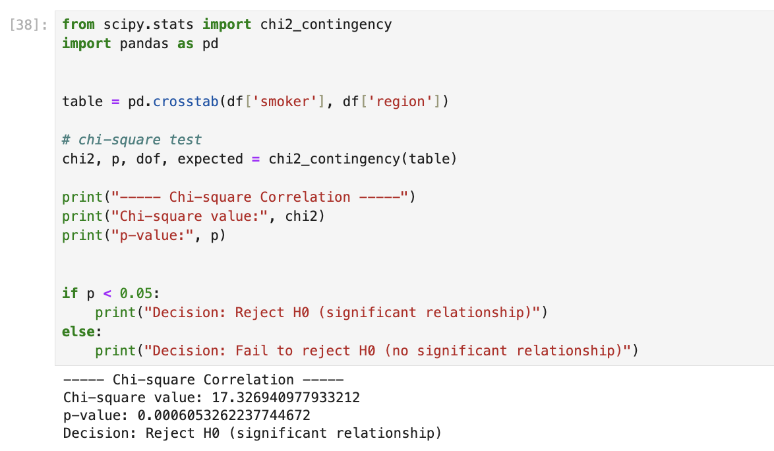
Chi-Square Test

Hypotheses
H₀: There is no association between smoking status and region.
H₁: There is an association between smoking status and region.
Results
Chi-Square Value: 17.33
P-value: 0.000605
Interpretation
Since the p-value is less than 0.05, we reject the null hypothesis.
This means there is a statistically significant association between smoking status and region.

One Sample T-test (2 points)

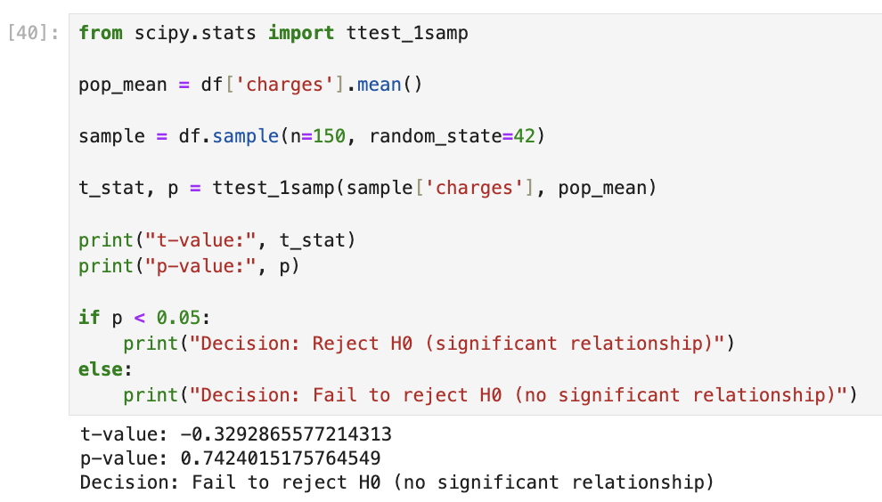

The one-sample t-test was performed to determine whether the mean insurance charges of the random sample (n = 150) are significantly different from the population mean.
Hypotheses
H₀: The sample mean of insurance charges is equal to the population mean.
H₁: The sample mean of insurance charges is not equal to the population mean.
Results
T-statistic: (-0.3293)
P-value: (0.7424)
Interpretation
Since the p-value (0.7424) is greater than 0.05, we fail to reject the null hypothesis. This means there is no statistically significant difference between the sample mean and the population mean.
Therefore, the random sample of 150 records is representative of the overall dataset in terms of insurance charges.

Refrence
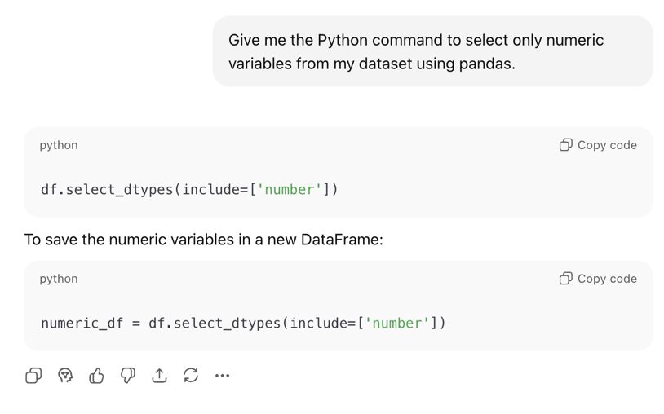

I used this command because I faced an error when creating the heatmap. The dataset contains both numerical and categorical variables, and the correlation function only works with numeric data. To solve this problem, I used select_dtypes(include=['number']) to select only the numerical columns before calculating the correlation matrix.

